Name: Quang Huynh

Global 10

**African Resistance: Comparing Primary Sources**

DOCUMENT A - Edward Morel was a British journalist who lived for a time in the Congo.

*Nor is violent opposition to abuse and injustice henceforth possible for the African in any part of Africa. His chances of effective resistance have been steadily dwindling with the increasing perfectibility in the killing power of modern armament.*

*Thus the African is really helpless against the material gods of the white man, as embodied in the trinity of imperialism, capitalistic exploitation, and militarism.*

Source: Edward Morel, The Black Man’s Burden

DOCUMENT B

***From 1889 to 1913, Emperor Menelik II ruled Ethiopia, the only African nation to resist colonization. He wrote the following letter to the caliph of the Sudan to express his opposition to European expansion and his desire to strengthen his alliance with the Sudan.***

This is to inform you that the Europeans who are present round the White Nile with the English have come out from both the east and the west, and intended to enter between my country

and yours and to separate and divide us. And I, when I heard of their plan, dispatched an expedition,sending detachments in five directions. The group [of Europeans] who are near are the English and the French, who are located in the direction from which the Belgians came. And do you remember when I sent to you Kantiba Jiru, you wrote to me by him that you have men in the direction from which the Belgians came?; and I ordered the chiefs of [my] troops that if they met with them, they were to parley with them and explain [my] intention. And now I have ordered my troops to advance towards the White Nile. And perhaps [if] you heard the news from merchants or from others you might misunderstand my action, [so now] I have written to you so that you would understand the object [of this expedition]. And you look to yourself, and do not let the Europeans enter between us. Be strong, lest if the Europeans enter our midst a great disaster befall us and our children have no rest. And if one of the Europeans comes to you as a traveler, do your utmost to send him away in peace; and do not listen to rumors against me. All my intention is to increase my friendship with you, and that our countries may be protected from [their] enemies.

*from* G.N. Sanderson, “The Foreign Policy of Negus Menelik” in the *Journal of African History,* Vol. 5, 1964.

**Comparing Sources:**

1. **Which author supports the claim that the Africans should not resist imperialism?**

Edward Morel supports the claim that African should not resist imperialism in Document A in his “Black Man’s Burden.”

1. **What evidence does the author use to support his claim?**

The evidence that Edward Morel uses to support this claim is the past. Africans are helpless against the European technology, as shown in previous cases of imperialism, militarism, and capitalistic exploitations.

1. **According to Menelik II, what was the Europeans’ plan?**

According to Menelik II, the European’s plan was to separate and divide the inhabitants of Ethiopia. To separate the two countries through rumors.

1. **What steps did Menelik II take in response to the Europeans’ plan?**

Menelik II sent his troops to investigate about what is going on. Then, he orders his chiefs to talk with the Sudanese troops. He wanted to explain to the Sudan leader about the false rumors.

1. ***Making Inferences:* Based on your analysis of both documents, what can you infer about the methods some European countries used to control African land and peoples?**

I can infer that Europeans are using the tactic known as divide and conquer to control African people and their land.

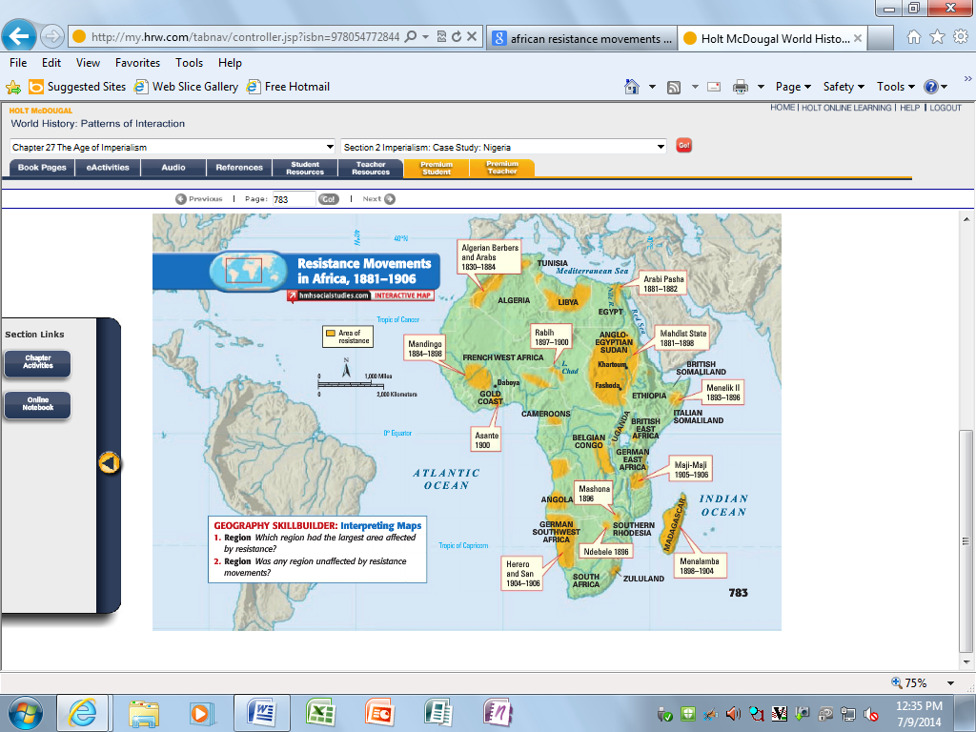

**Map Skills:**

1. **What region had the largest area affected by resistance?**

The region that had the most area affected by resistance is the Mahdist state.

1. **Was any region unaffected by resistance movements?**

No, I do not believe any region or state that were not affected by resistance movements. Although I believe that the region that had the least affect from resistance movements was Ndebele, which had the smallest area of resistance.